New Jersey War Related Illness and Injury Study Center (WRIISC)

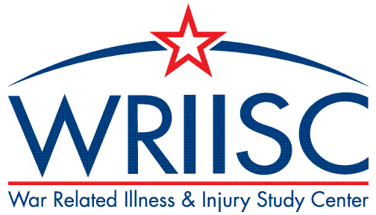

www.warrelatedillness.va.gov

The War Related Illness and Injury Study Center (WRIISC) is a national program dedicated to Veterans’ post-deployment health concerns and unique health care needs. We develop and provide post-deployment health expertise to Veterans and their health care providers through clinical care, research, education, and risk communication.

The WRIISC research program studies a wide range of topics including environmental exposures and post deployment health, long-term health effects of combat, memory and mood difficulties, traumatic brain injuries, neurological diseases, integrative health and wellness approaches, disabilities resulting from deployment illnesses or injuries, women Veterans’ health, and risk communication of deployment related concerns. Researchers and clinicians work together to identify health concerns and use the knowledge generated to identify promising treatments and evidence-based care for the Veterans.

The WRIISC also houses the VA’s Airborne Hazards and Burn Pits Center of Excellence (AHBPCE). The AHBPCE was formally recognized as a VA Center of Excellence in 2019 (Public Law 115-929), and as part of its mission, conducts a program of clinical and translational research related to health effects of airborne hazards and burn pits exposure. Active VA and DoD funded projects explore mechanisms of dyspnea and exercise intolerance, effects of blast overpressure injury, as well as novel approaches to small airway assessment. These efforts are in collaboration with our academic and federal partners.

For more information on research being done at the WRIISC, please call 1-800-248-8005 or email wriisc.nj@va.gov.

