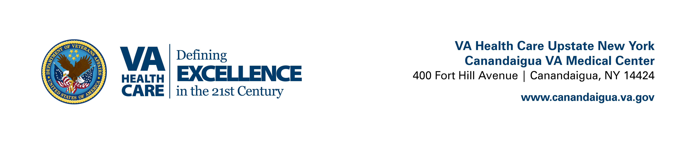
The Canandaigua VAMC & Rochester VA Outpatient Clinic Values our Volunteers!
We recognize the worth of our Volunteers as they share their time, talents, and energy. Every day Volunteers help us provide the highest quality of care to our Veterans.
For more information, call Voluntary Service at (585) 393-7761.

Volunteer Assignments:
There are multiple assignments for Volunteers at the Canandaigua VA, including the Rochester Outpatient Clinic. Areas include: escorting Veterans to appointments, clerical, recreational activities, friendly visits and more. Please indicate your assignment preference(s) on the Volunteer Application. Ensure 2nd page of application is signed by appropriate parties for any volunteers under age 18! We love Youth Volunteers!

Requirements to Volunteer:
- It is preferred that all new Volunteers attend one of our weekly Orientations held each Thursday at 10:00 am at the Canandaigua VAMC, Building 7, Room 19. Fingerprints will be taken at this time. Allow yourself 1.5 hours. Call (585) 393-7761 to reserve your spot today!
- New Volunteers have the option of printing and completing the below documents at home and mailing/e-mailing them to Voluntary Service or bringing them on Orientation day. Hard copies may also be provided and can be completed at that time.

Complete the following documents:
- Fill out and sign Volunteer Application
(Please provide e-mail address if you have one for occasional volunteer needs/updates)
- Sign the Statement of Commitment of Understanding
- Read the Orientation Packet, print and sign the front page
- Completely fill out the Fingerprint Background Check/ID Badge form

3. Prior to volunteering, VA requires a fingerprinting background check and a TB test for individuals age 18 or older. Please refer to page 12 of the Orientation packet for more information. Both of these can be done at either the Canandaigua VAMC or the Rochester VA Outpatient Clinic. We require the TB test be done no sooner than 2 business days following the fingerprinting.
Remember: Please allow several weeks for Background Checks to be completed.
Volunteer Drivers:
Are you interested in becoming a Volunteer Transportation Network Driver to help our local Veterans get to their appointments? If so, please review the Health Screening Checklist and if you qualify, contact the Voluntary Service Office to discuss additional requirements below.

Note: Drivers operate vans donated by the Disabled American Veterans for this purpose, and are insured and fueled by VA – there are no expenses to the Volunteer driver.

ADDITIONAL REQUIREMENTS FOR DAV DRIVERS

DAV Driver Physical | Call for appointment after meeting with Voluntary Service regarding additional training requirements and assignment details.  *All physicals are held at The Canandaigua VAMC and must be done by our Employee Health Physician | Canandaigua: (585)393-7803
Police License Check | Following Orientation | Completed by Voluntary Service
Valid Driver’s License | Prior to Driving | Copy to Voluntary Service
Insurance | Prior to Driving | Copy to Voluntary Service
Credit Card “Do’s and Don’ts” | Prior to Driving | Signed Copy to Voluntary Service
Defensive Driving Course | Prior to Driving | Signed Copy to Voluntary Service

Contact Voluntary Service at (585) 393-7761 with any questions or concerns. We appreciate your patience as we continue to meet mandated requirements to safeguard our Nation’s Heroes!
Revised 08/26/15

